Interlochen Area Chamber of Commerce Presents:
Business After Hours
Wednesday, February 28th ~ 5:30 PM
Hosted by:
Morse Moving & Storage
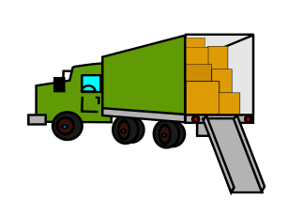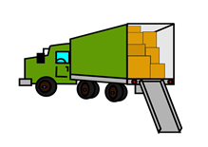

2040 Traversefield Dr, Traverse City
(north off Hammond just east of Garfield Rd)
www.interlochenchamber.org/business-after-hours
Business After Hours is a great way to unwind and network in a relaxed setting.
Bring your Business Cards, Your Friends & Your Appetite!
$5.00 Donation at the Door

