INTERLOCHEN AREA CHAMBER OF COMMERCE
PRESENTS
BUSINESS AFTER HOURS
NOVEMBER 20, 2019 ~ 5:30 pm
(NOTICE THE EARLY DATE DUE TO THANKSGIVING)

OUR HOST:
INTERLOCHEN FAMILY CHIROPRACTIC
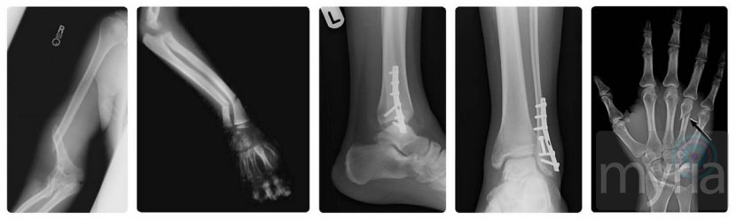
Dr Paul Kelly
9676 us 31 soUTH Suite 300~ Interlochen
Between Subway and Hairold’s Salon

We promise not to crack your bones, just come and meet our newest member, have a snack and mingle with each other. It’s going to be a great time! Our last until after the Christmas Holidays!

