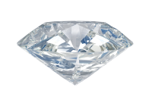

Bangles, Baubles and Bags Gala Event
Fundraiser for Interlochen Public Library
August 10, 2019 10 AM ~ 4 PM

Calling all fashionistas, jewelry freaks and purse-obsessed for the “Bangles, Baubles and Bags” gala sale to support IPL. Gently used and new Fine and costume jewelry, purses and scarves will be for sale August 10, 2019 from 10 to 4 in the community room at the Library. Preview party for Friends of the Library August 9 from 5-7 (Public may join the Friends at the door Friday for $15 and enjoy a first chance at the sale.). A silent auction of fine jewelry, art and purses will run during the sale. All proceeds support children’s and adult programming at the library. The Library is located at 10th St and M-137 next to Bud’s Cafe. For further info call 231-620-1331. Those wishing to donate items for the sale may drop them at the Library.

Any questions, just call.

