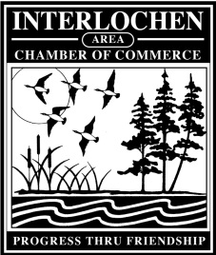
Interlochen Area Chamber of Commerce
2018 Membership Application

Member Benefit | Business | Non-Profit | Individual
Area Guide Listing (**see below) | • | •
Quarterly Newsletter | • | • | •
Brochure Display | • | •
Voting Privileges | • | •
Calendar of Events | • | •
Email Communications | • | • | •
Sponsorship Opportunities | • | •
Additional Listings $25 | • | •
Newsletter Advertising | • | •
Business After Hours | • | • | •
Membership List Access | • | •
Area Guide Ads | • | •
Web Page Listing, Web Link | • | •
Ribbon Cutting Ceremony | • | •
Member Spotlight on Website | • | •
Involvement in Your Community | • | • | •
Member Referrals | • | •
Special Events Invitations | • | • | •
** Distribution: 10,000+ Copies; Michigan Welcome Centers, TC Visitor Center, Locally
Please complete and send to: DUES:
INTERLOCHEN AREA CHAMBER OF COMMERCE $320 2-Yr. Business
P.O. Box 13, Interlochen, MI 49643 $180 1-Yr. Business
info@interlochenchamber.org $100/Yr. Non-Profit
Dues are tax deductible as a business expense as the Chamber is a non-profit organization. $50/Yr. Individual
Business Name: _______________________________________Contact Person: _______________________________
Address: _________________________________________________________________________________________
Phone: _____________________________________________ Fax: _________________________________________
Email: _______________________________________ Website:____________________________________________
Give a brief description of your business: _________________________________________________________________________________________________
_________________________________________________________________________________________________
_________________________________________________________________________________________________

Signature: _______________________________________ Date: ___________________________

